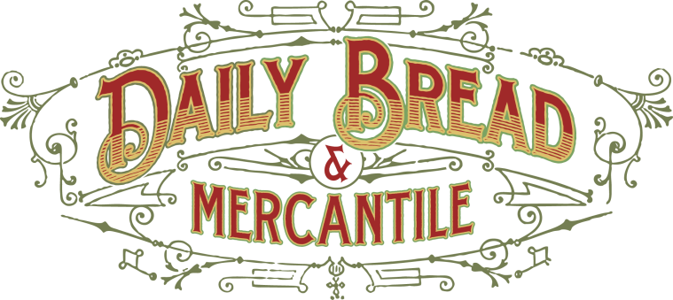

Lunch for Catering

Sandwich Lunch Boxes: $ 13.50 ea. **most popular**
- Whole Sandwich
- Bag of chips
- One cookie
- Mayo and mustard packets
- Mint, Napkin and knife

Sandwich/Soup Lunch Boxes: $ 16.15 ea.
- Whole sandwich
- Cup of soup
- One cookie
- Mayo and Mustard Packets
- Mint, Napkin, Knife, and Spoon

Tray Of Sandwiches (minimum of 10) : ( $ 8.05 ea. )

Sandwich Choices for your Sandwich Platter or Box Lunches:
All sandwiches will come with whole wheat or multigrain bread, lettuce, sweet onion, and tomato with spread on the side, unless otherwise noted.
- Ham & Swiss
- Turkey & Marble
- Roast Beef & Provolone
- Buffalo Chicken & Pepper Jack
- ALL the Veggie with or without cheese

Soup: 1 gallon of soup: ( 10 ½ 12oz. servings) : $35.80

Your Selection of Meat and Cheese Platter: $11.99 a lb

Tray of Cookies: $12.72 per dozen

Drinks:
- Cans of pop: $1.25 (pepsi, diet pepsi, coke, diet coke,sprite, diet dr. pepper)
- Bottled Water: $1.25
- Bottled Tea $3.65 (sweetened and unsweetened)

Salads:
- Potato or Pasta: $9.25 a lb. (35 ppl per gallon; 6# in a gallon)
- Green Garden Salad $11.95 a lb. (1 lb. would serve 8-10 ppl., depending on other amounts of food)
- Fruit and Veggie Tray: Small: $25 Medium: $45 Large: $65

Paper Products: $ 1.50 per person (depending on amount of items)

Want it delivered?? 15 people is the Minimum
$15 rate for every delivery

Feel Like Tipping?
Feel free to communicate your desired amount.

Want to know what else we have on our menu? Or feel like being more creative?
Just ask. We don’t mind..

Tax will be included.

Feel free to email or call in your order. (509-925-2253) (dbandmerc@gmail.com)

An Invoice can be made for you once order is finalized.

How will you be paying?
We take all cards, checks, and cash payment. Pre payment is required if amount is over $500.

