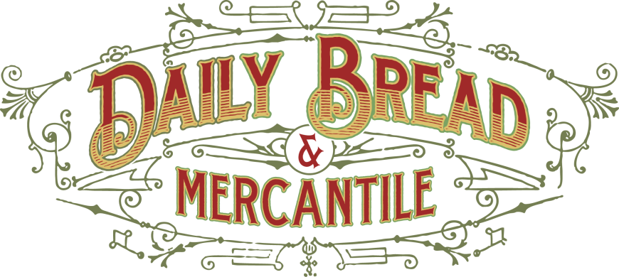
Daily Bread Breakfast Catering Menu

Single Cinnamon Rolls: $41.35 a dozen
regular with plain or maple glaze, orange rolls, or raspberry rolls
Single Scones:$ 40.75 a dozen
raspberry white chocolate, savory, blueberry, peach, lemon coconut, pumpkin, and more
Single medium size Muffins: $33.66 a dozen
Apple, Blueberry , or Pumpkin Streusel
Breakfast Sausage, Lorraine, Veggie, or Ham & Swiss
Coffee Carafe(serves 10-12): $40

dbandmerc@gmail.com / 509-925-2253

